Docker Challenges
- Create a customized Docker image using a Dockerfile.
Create HTML File
vi index.html
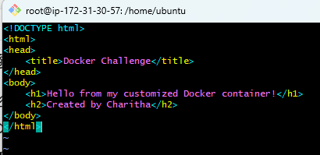
Create Dockerfile
vi Dockerfile
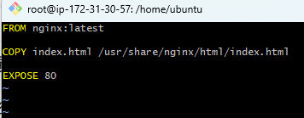
docker build -t my-custom-nginx .
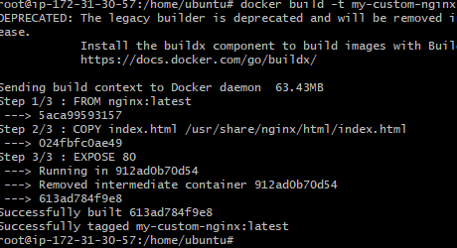
Run Container
docker run -d -p 8080:80 --name nginx-container my-custom-nginx
docker ps
curl localhost:8080
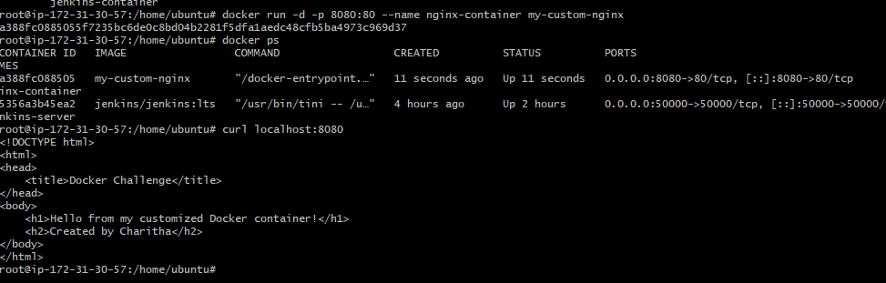
verified my custom HTML page.
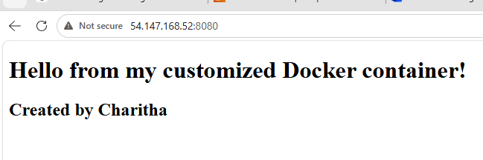
- Push the image to Docker Hub.
Login to Docker Hub
docker login
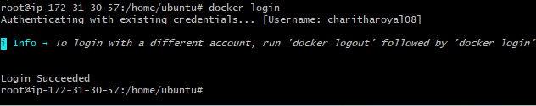
Tag the image
docker tag my-custom-nginx:latest charitharoyal08/my-custom-nginx:latest
Verify tag
docker images
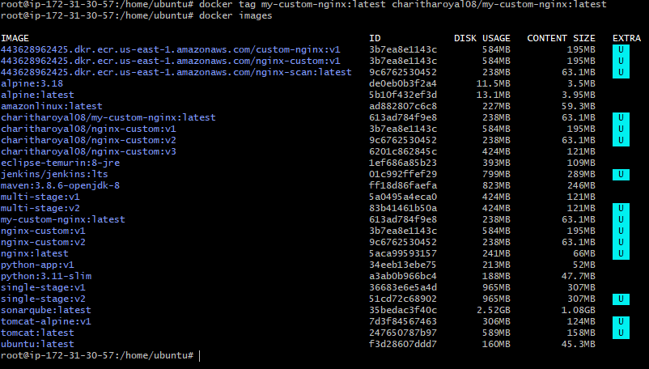
Push to Docker Hub
docker push charitharoyal08/my-custom-nginx:latest
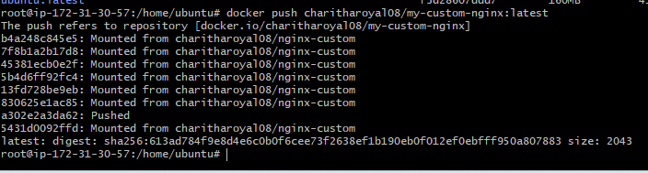
verified in Docker Hub repository page and confirm that my-custom-nginx appears.

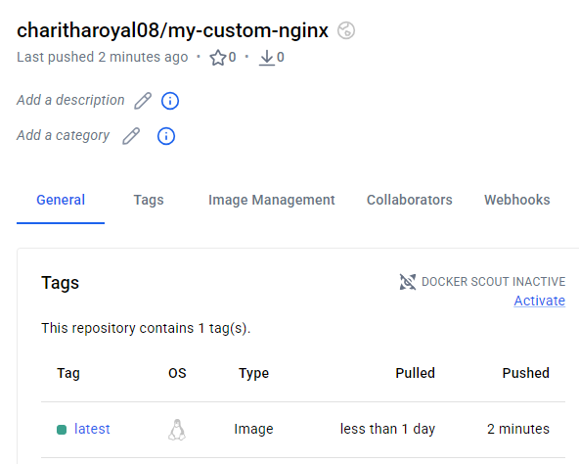
- Push the same image to Amazon ECR.
Verify AWS CLI Configuration
aws sts get-caller-identity
Create ECR Repository
aws ecr create-repository --repository-name my-custom-nginx
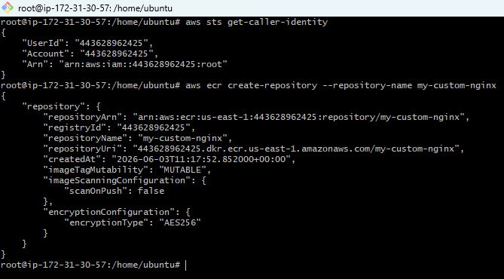
Login Docker to ECR
aws ecr get-login-password --region us-east-1 | docker login --username AWS --password-stdin 443628962425.dkr.ecr.us-east-1.amazonaws.com
Tag the Image
docker tag my-custom-nginx:latest 443628962425.dkr.ecr.us-east-1.amazonaws.com/my-custom-nginx:latest
docker images
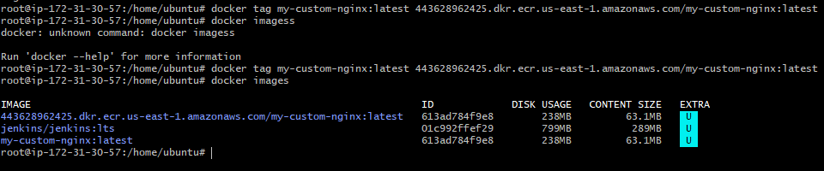
Push Image to ECR
docker push 443628962425.dkr.ecr.us-east-1.amazonaws.com/my-custom-nginx:latest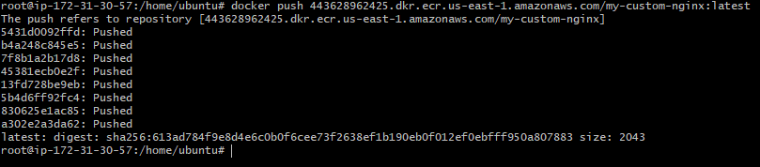
Verify in AWS Console
AWS Console→ ECR→ Repositories→ my-custom-nginx→ Images
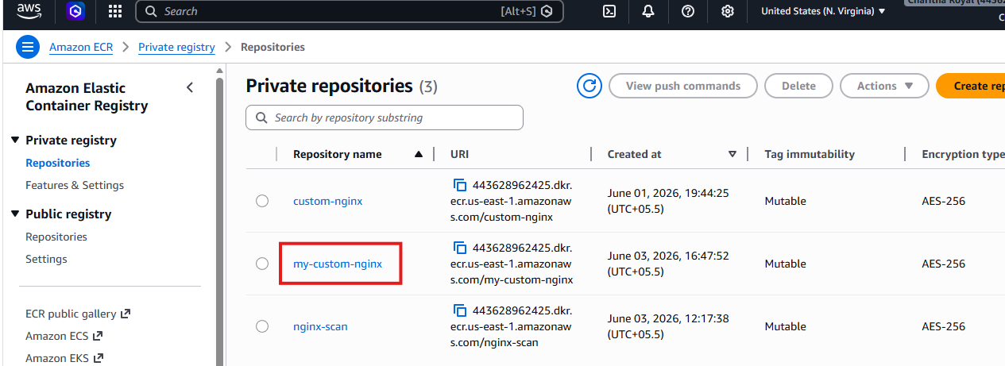
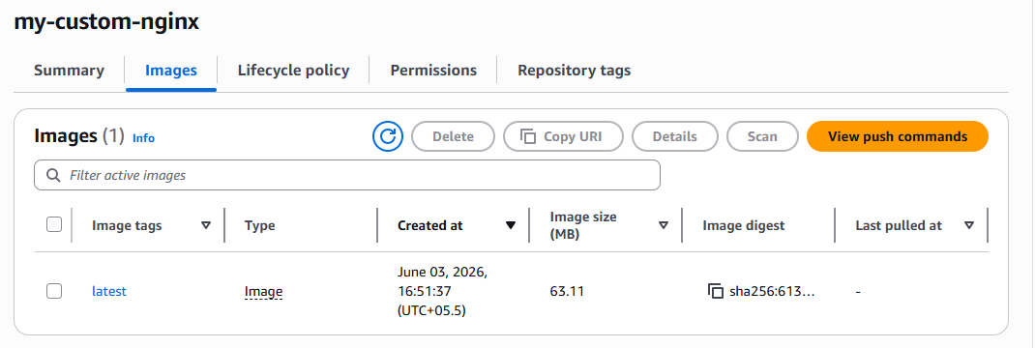

- Provision one EC2 instance using Terraform and install Jenkins.
sudo apt update
sudo apt install -y gnupg software-properties
common curl
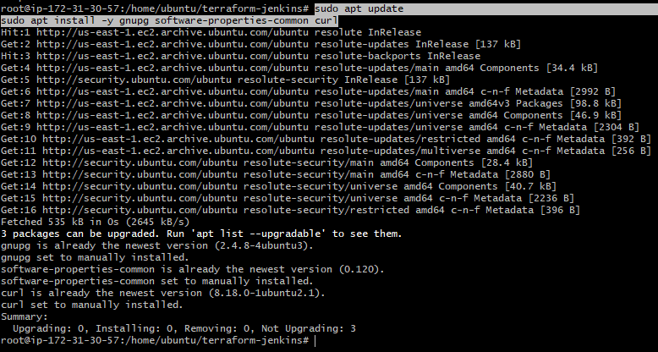
installed terraform
sudo apt install -y terraform
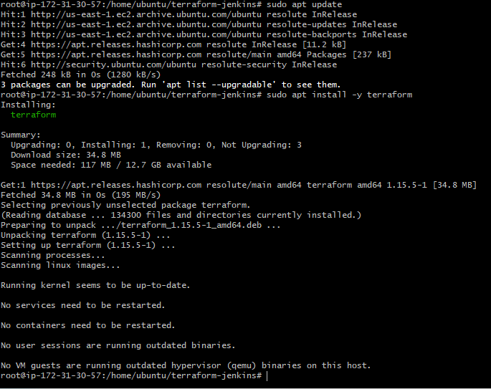
Now let's verify your AWS Key Pair name before running Terraform.
aws ec2 describe-key-pairs --query "KeyPairs[*].KeyName" --output table
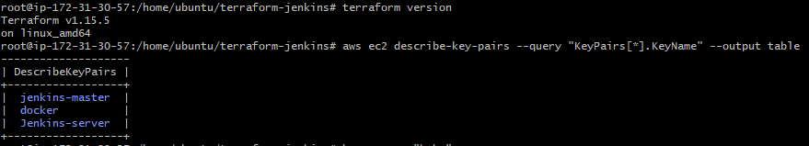
mkdir terraform-jenkins
cd terraform-jenkins
vi main.tf
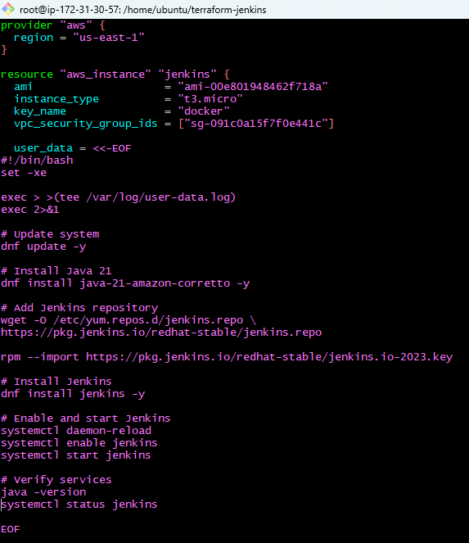
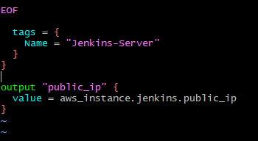

terraform fmt
Initialize Terraform
terraform init
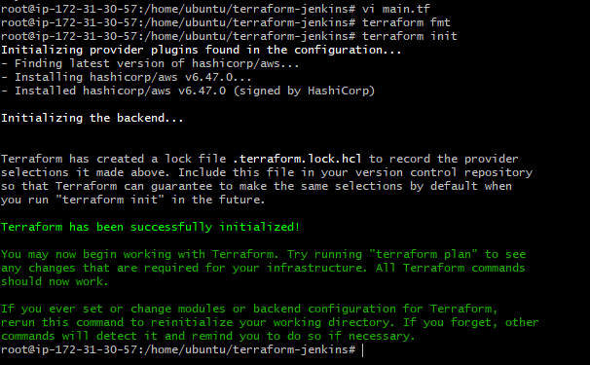
terraform validate
terraform plan
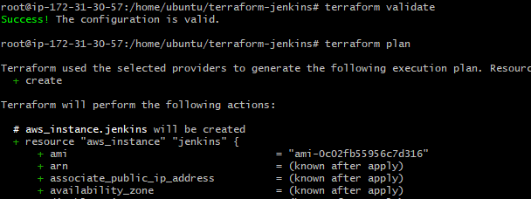
terraform apply
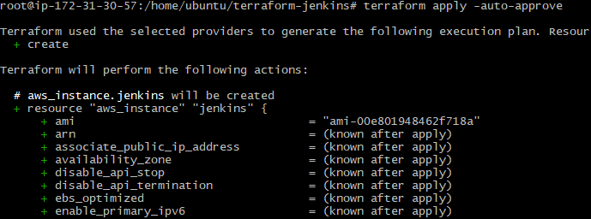
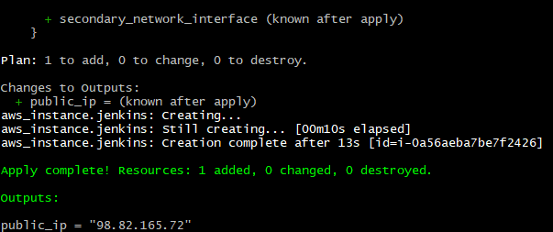
A new EC2 instance was successfully provisioned through Terraform, with Jenkins automatically installed and running.
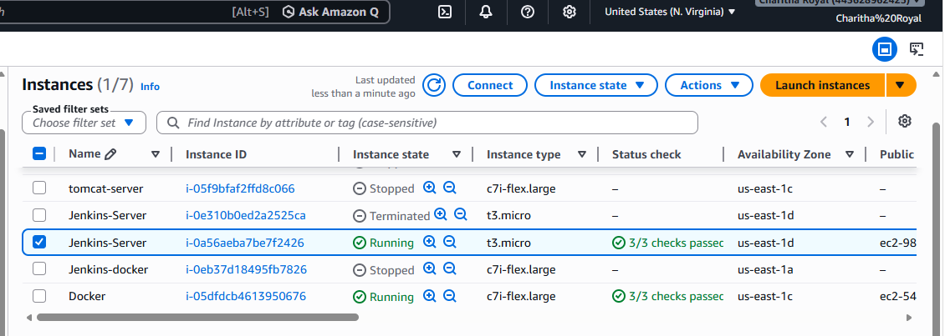
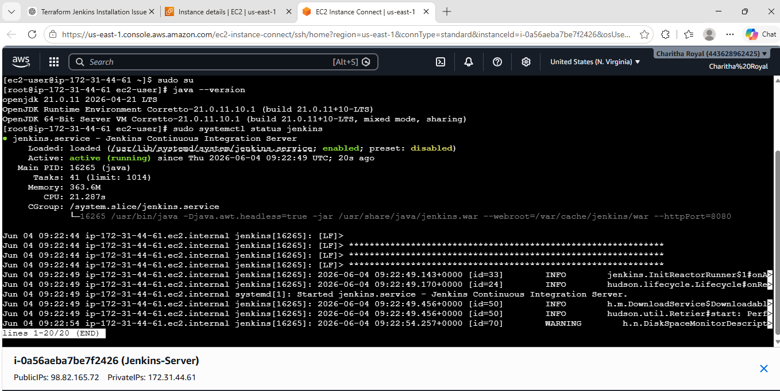
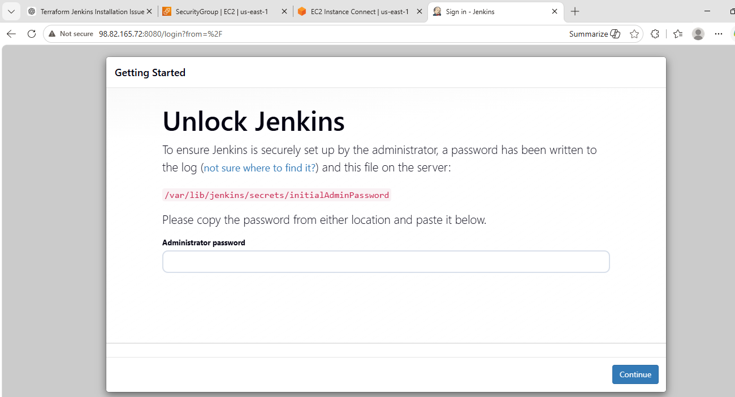
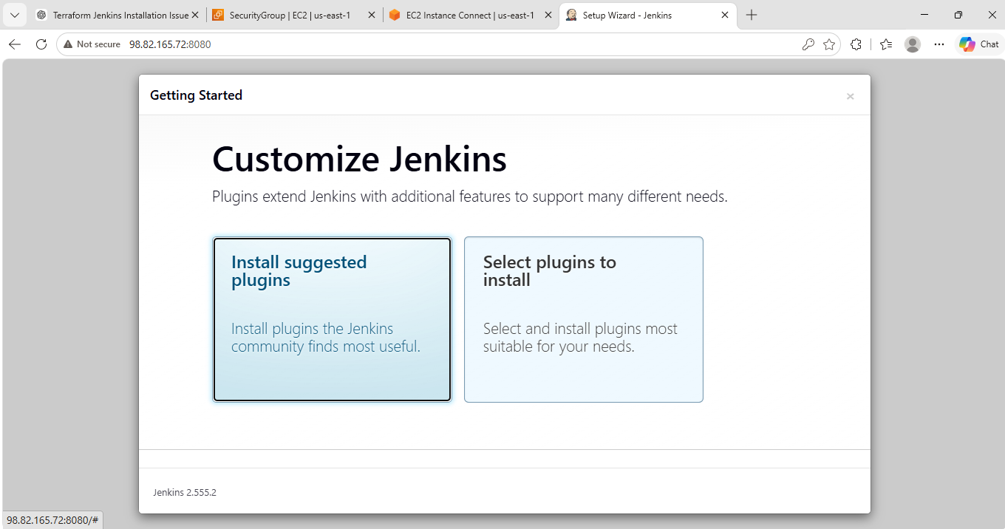
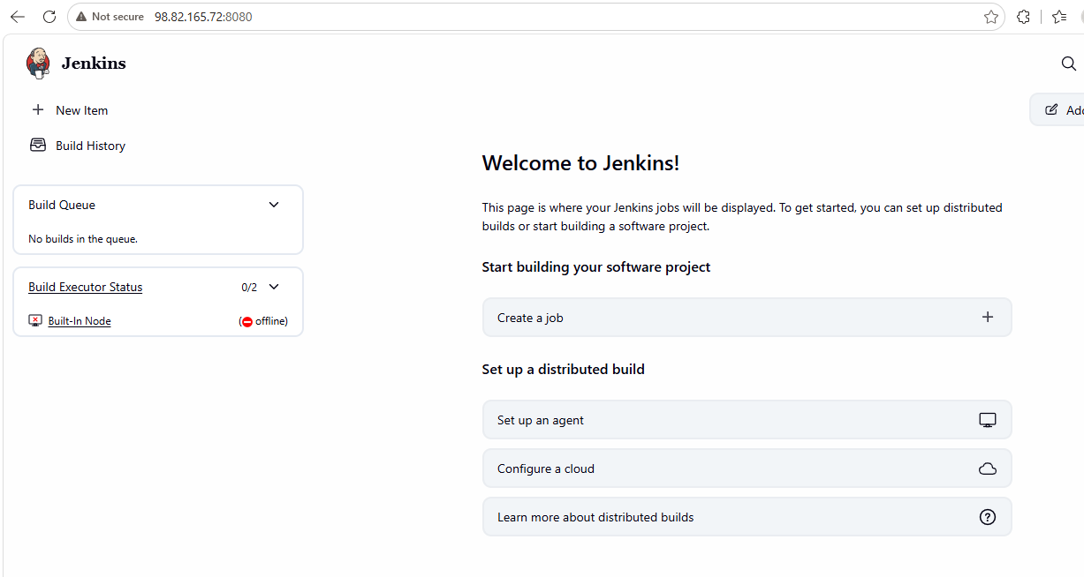
- Create one Jenkins job to build and push the Docker image to Docker Hub.
  - Source:https://github.com/betawins/Python-app.git

First lets add docker hub credentials in Jenkins server
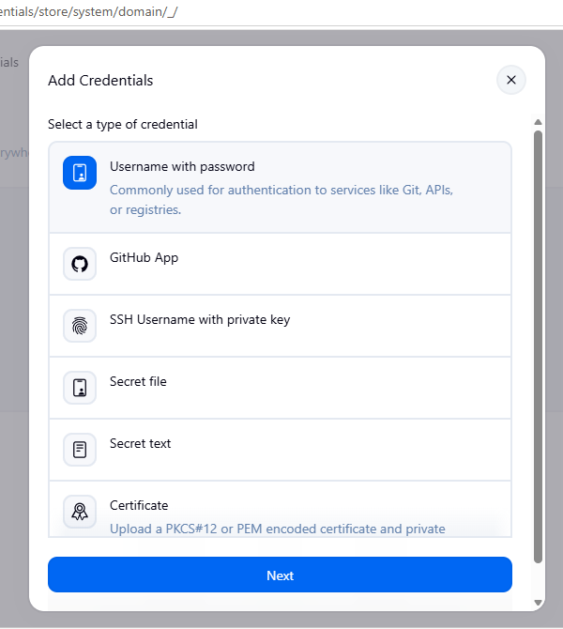
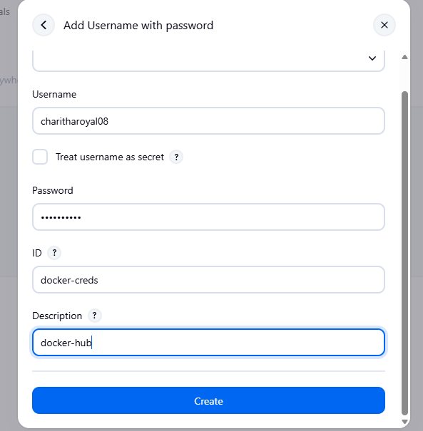
Now install the docker pipeline plugin
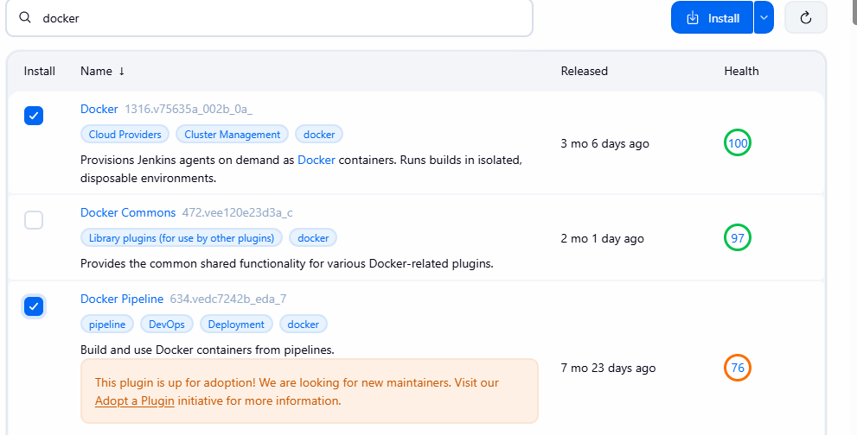
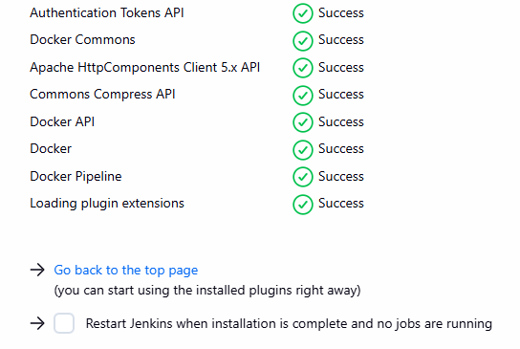
created a new pipeline job
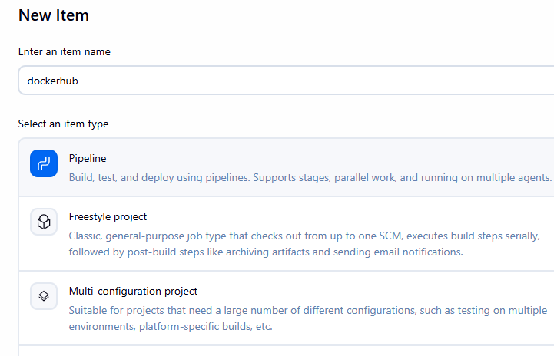
pipeline script
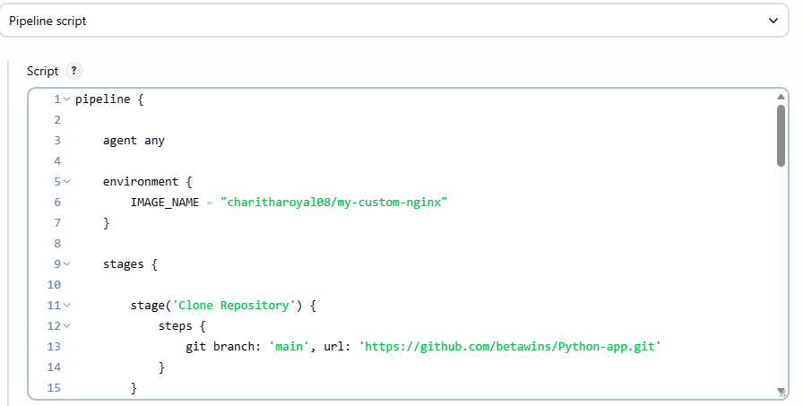
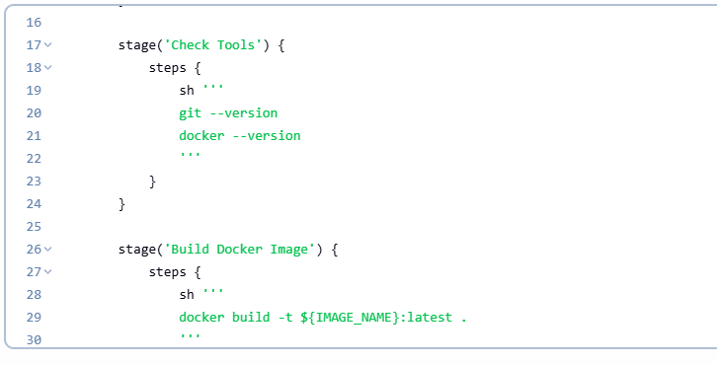
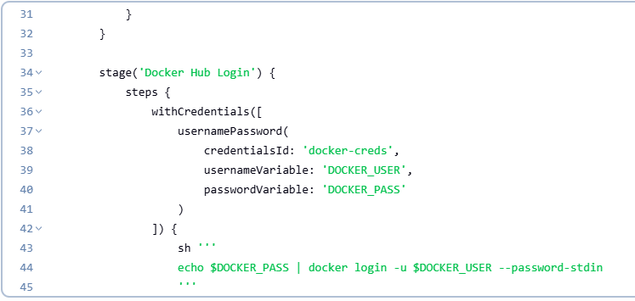
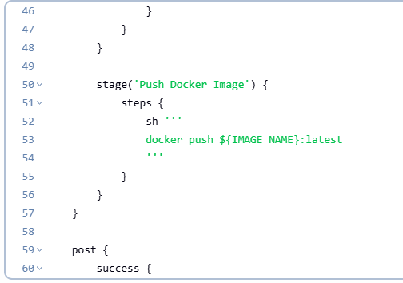
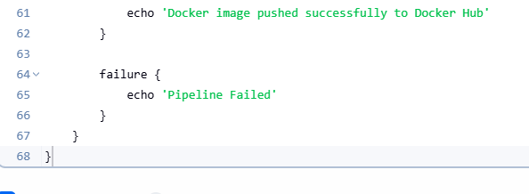
Build success
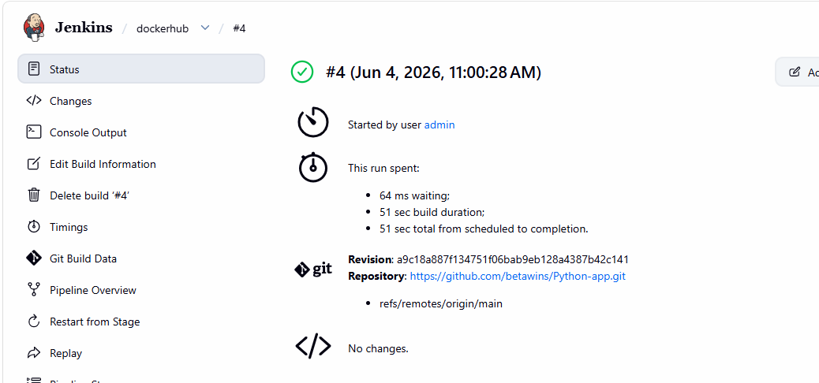
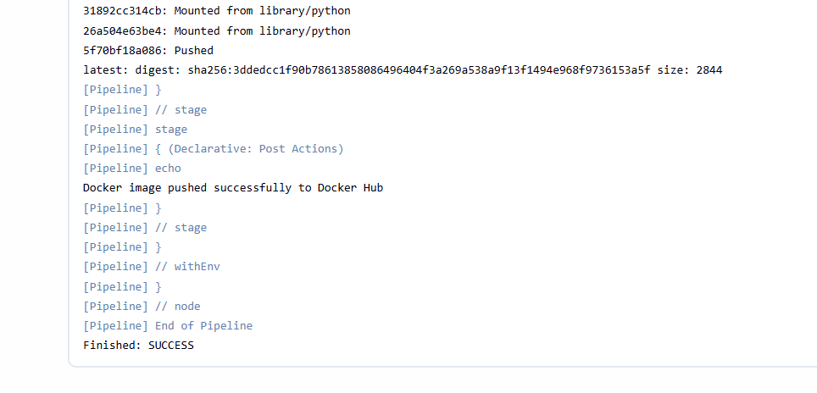
Check in Docker Hub Repo
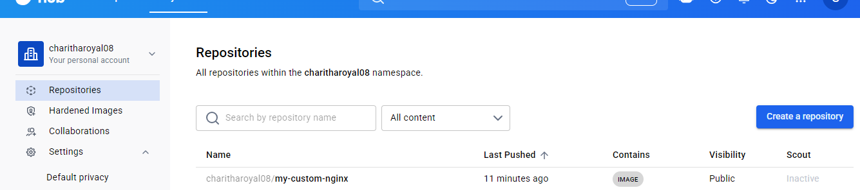

Source: https://github.com/betawins/Python-app.git
Source Codes: https://github.com/betawins/docker-tasks.git
1.From the frontend source code, write a Dockerfile, build a Docker image, run it, and push that image to your Docker registry.
Clone Source Code
git clone https://github.com/betawins/docker-tasks.git
cd docker-tasks
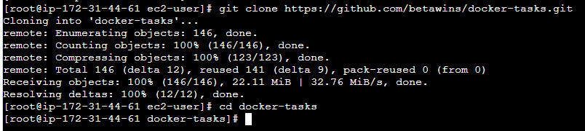
Docker Version and Git Version
docker –version
git –version
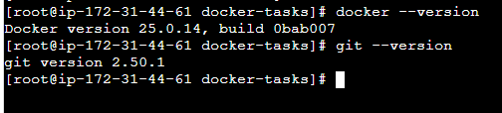
cd Frontend_based_source
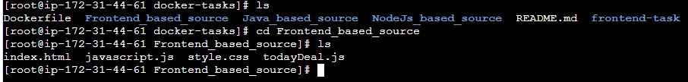
Create Dockerfile
vi Dockerfile
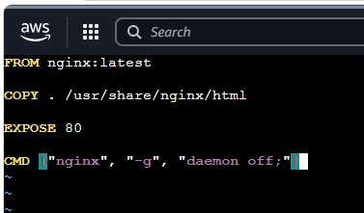
Build Frontend Image
docker build -t frontend-app .
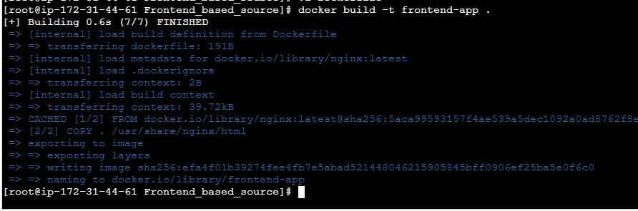
Verify Image
docker images
Run Frontend Container
docker run -d --name frontend-container -p 8081:80 frontend-app
access in browser

verify running container
docker ps
docker login
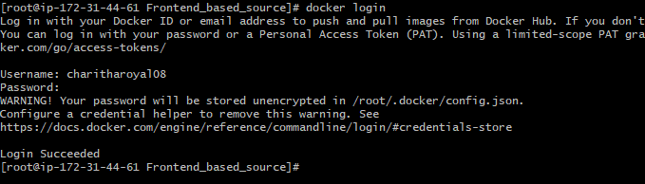
now push to Docker Hub
docker tag frontend-app charitharoyal08/frontend-app:v1
docker push charitharoyal08/frontend-app:v1

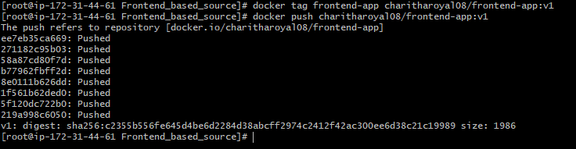
verify on docker hub
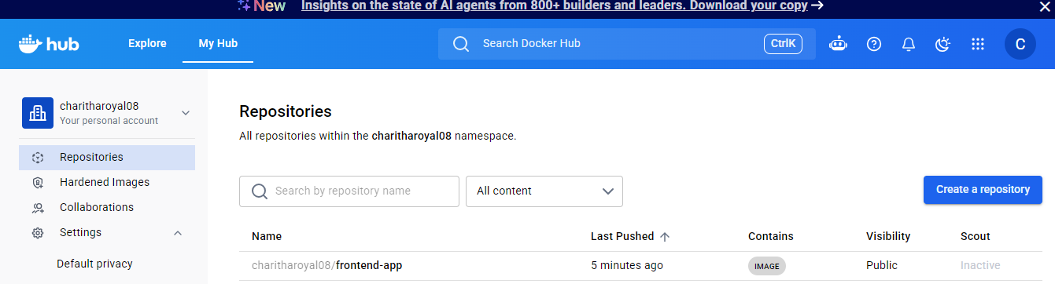

2.From the Java-based source code, write a Dockerfile, build, run, and push the image to the Docker registry.
cd docker-tasks
cd Java_based_source
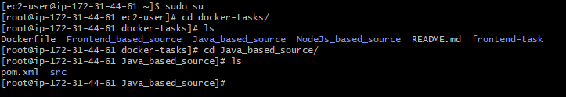
install java and maven
sudo yum install -y java-17-amazon-corretto maven

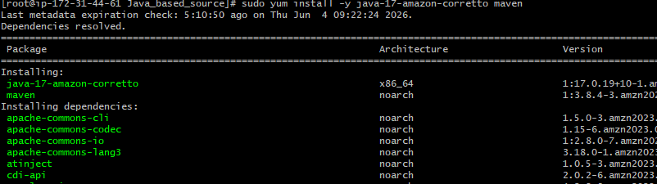
java -version
mvn -version
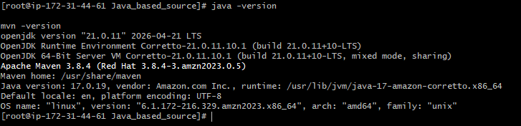
Build Java Application
mvn clean package
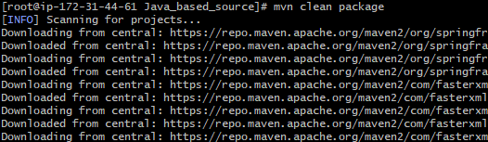
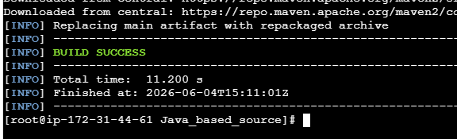
Create dockerfile
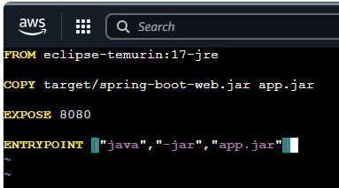
build docker image
docker build -t java-app .
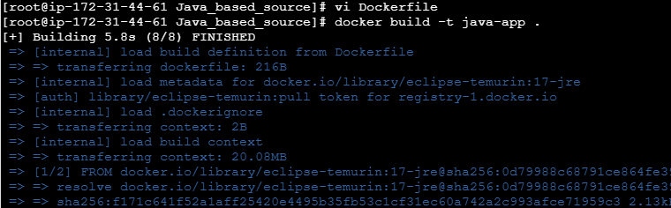
Run Container
docker run -d -p 8081:8080 --name java-container java-app
docker ps
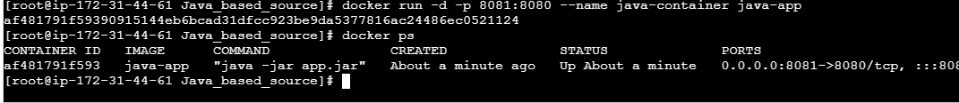checking logs
docker logs java-container
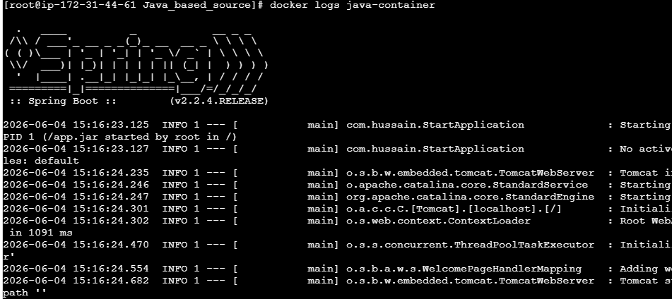
access application
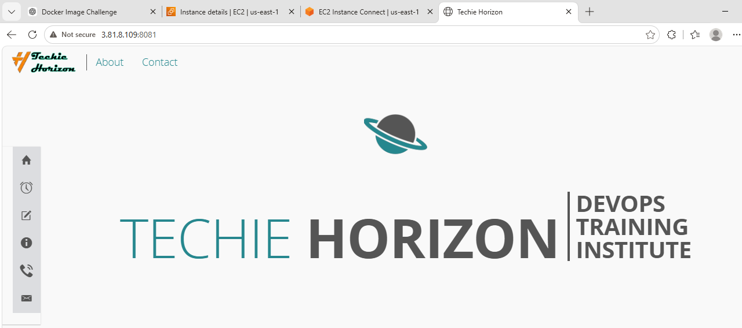
docker login
docker images
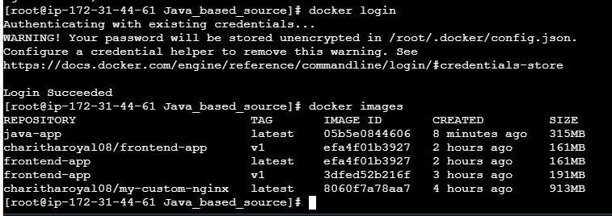
Push to Docker Hub
docker tag java-app charitharoyal08/java-app:v1
docker push charitharoyal08/java-app:v1
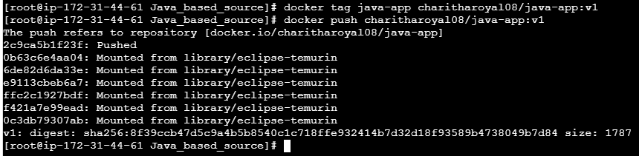
verify on docker hub
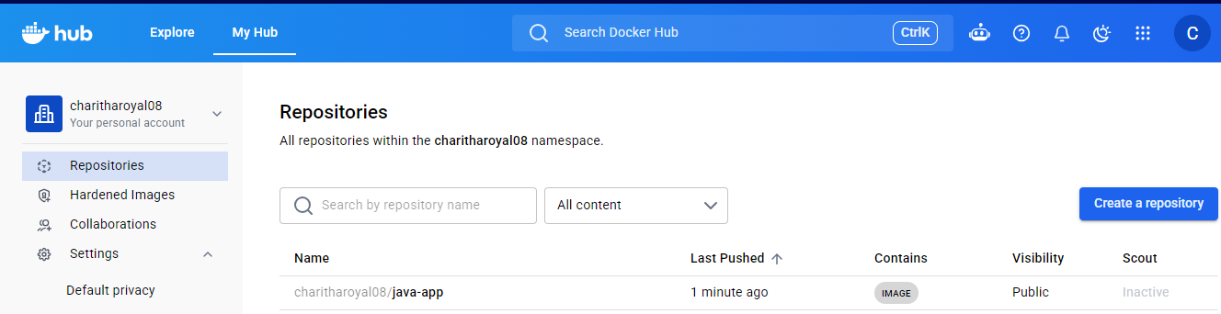

3.From theNode.js-based source code, write a Dockerfile, build with tagv1, run, and push it to the Docker registry.
cd docker-tasks
cd NodeJs_based_source
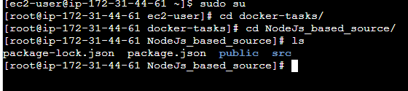
Create a Dockerfile
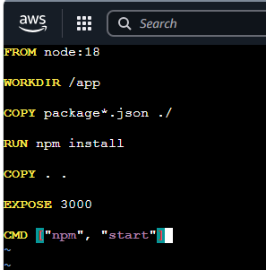
Build Image with Tag v1
docker build -t node-app:v1 .
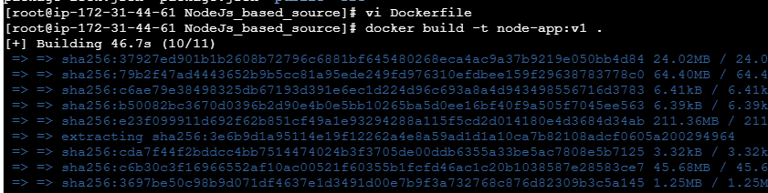
Run Container
docker run -d -p 3000:3000 --name node-container node-app:v1
docker ps
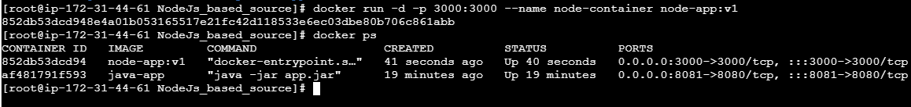
Verified the application

Push to Docker Hub
docker tag node-app:v1 charitharoyal08/node-app:v1
docker push charitharoyal08/node-app:v1
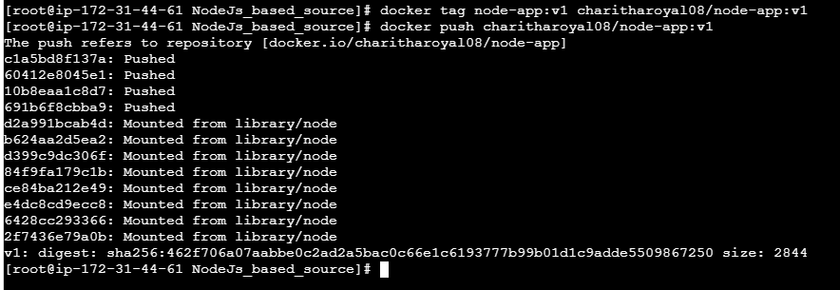
verify on docker hub
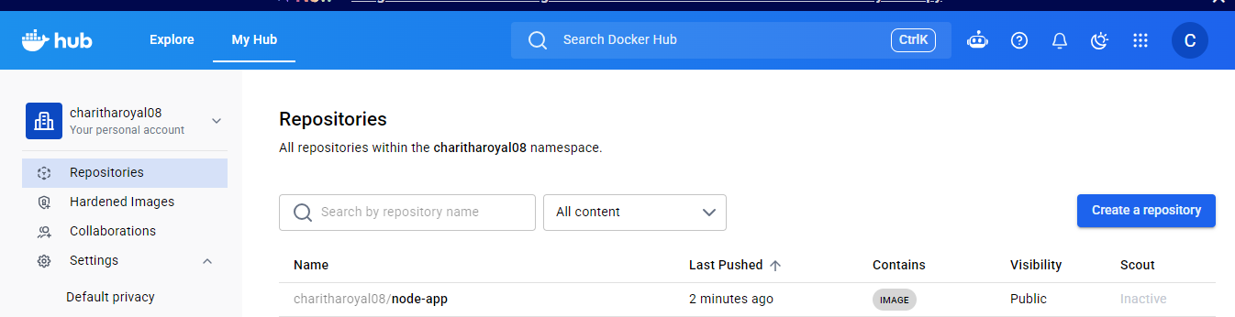

4.Write a docker-compose file to set up WordPress with a MySQL database.
Create Project Folder
mkdir wordpress-compose
cd wordpress-compose
Install Docker Compose
sudo curl -L "https://github.com/docker/compose/releases/latest/download/docker-compose-linux-x86_64" -o /usr/local/bin/docker-compose
sudo chmod +x /usr/local/bin/docker-compose
docker-compose –version
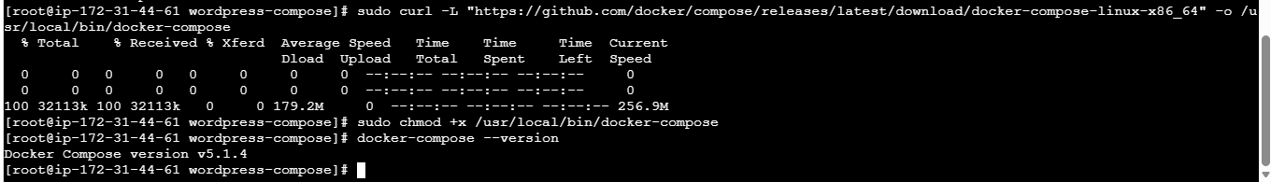
Create docker-compose.yml File
vi docker-compose.yml
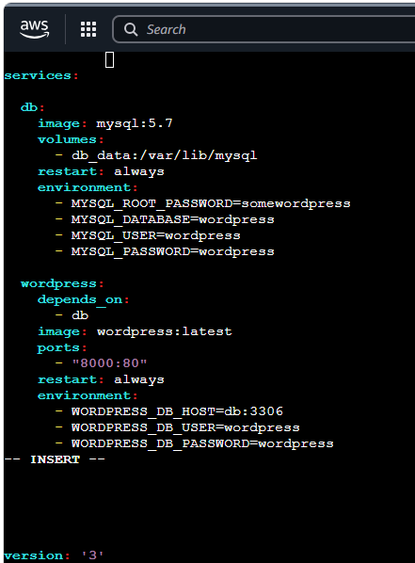
start container
docker-compose up -d
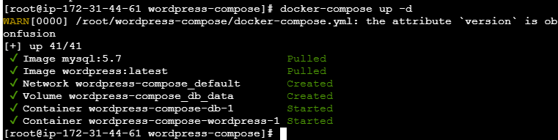
Verify Running Containers
docker ps
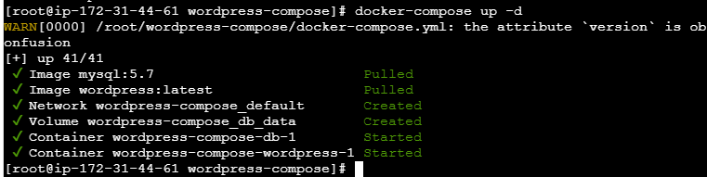
Verify Docker Compose Services
docker-compose ps
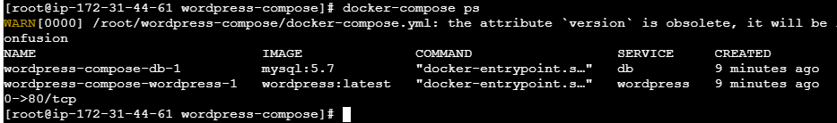
Access WordPress with port no 8000 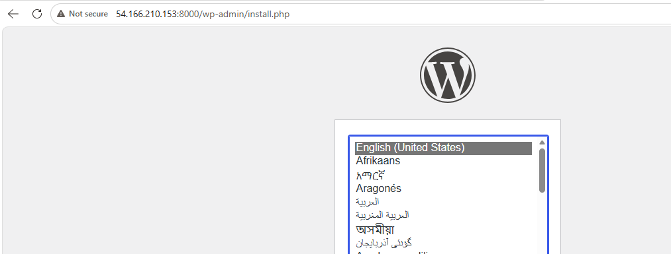
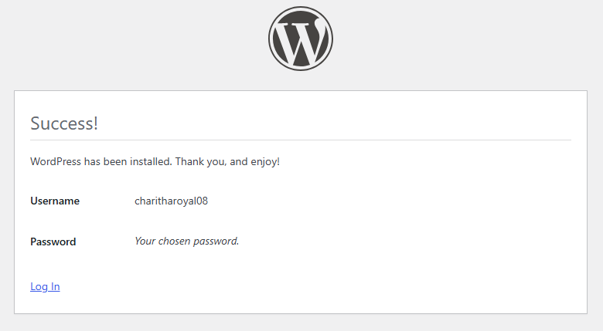
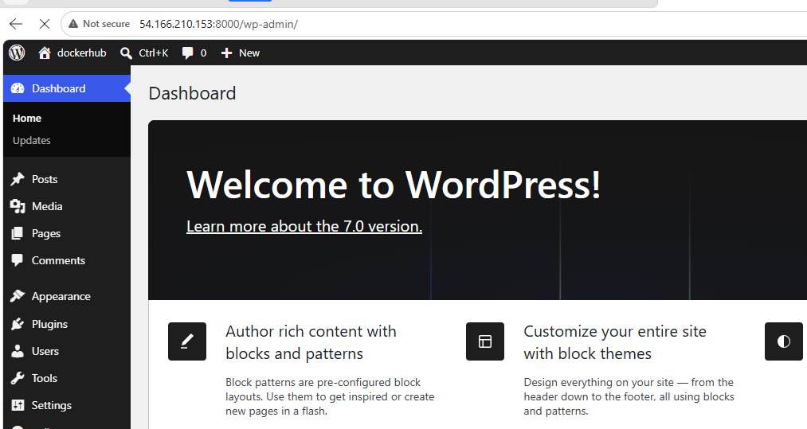
Verify Persistent Volumes
docker volume ls
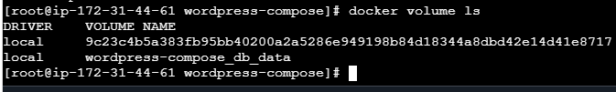
Stop Containers
docker-compose down
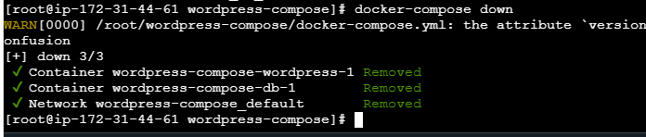
Restart Containers
docker-compose up -d
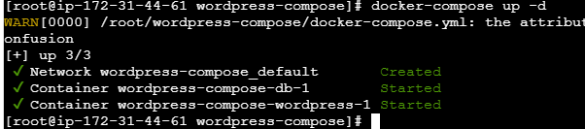
View Logs
docker-compose logs
